**MACHINE LEARNING WITH PYTHON**

A Project Report Submitted to the Bharathidasan University in partial

fulfillment of requirement for the award of the degree of

**BACHELOR OF COMPUTER SCIENCE**

Under the guidance of

**Dr. K. ELANGOVAN, M.Sc., M.Phil., Ph.D**

Guest Lecturer



**DEPARTMENT OF COMPUTER SCIENCE**

**GOVERNMENT ARTS AND SCIENCE COLLEGE (Co-Ed),**

(Affiliated to Barathidasan University)

**THARAGAMPATTI-621 311.**

**APRIL -2023**

PROJECT REPORT

Intelligent Customer Retention: A Progressive Approach to Health Management

**Team Leader** - Ganesan R

**Team Member**  - Mangalaraja v

## Team Member - Gowtham s

## 

## Team Member - Palanisamy A

Intelligent Customer Retention: Using Machine Learning for Enhanced Prediction of Telecom Customer Churn

# OVERVIEW:

Artificial intelligence (AI) has gradually become accepted by colleges and universities as an effective tool for automating a number of tasks effectively and efficiently.AI-generated emails can remind students about important deadlines, prompt them to register for classes, turn in assignments and pay their fees on time and, in a particularly controversial use. AI-based software is increasingly able to detect plagiarized assignments. AI expands into these core university practices, new concerns are also being raised about the tools threats to personal privacy and its vulnerability to systematicbias.

# Technical Architecture:

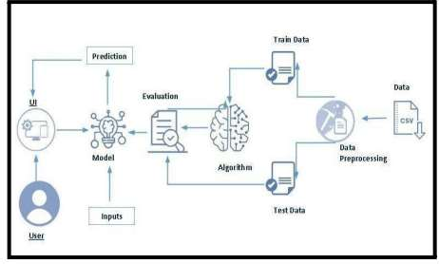

**Technical about the Project:**

Machine learning is merely based on predictions made based on experience. It enables machines to make data-driven decisions, which is more efficient than explicitly programming to carry out certain tasks. These algorithms are designed in a fashion that gives exposure to new data that can help organizations learn and improve their strategies.

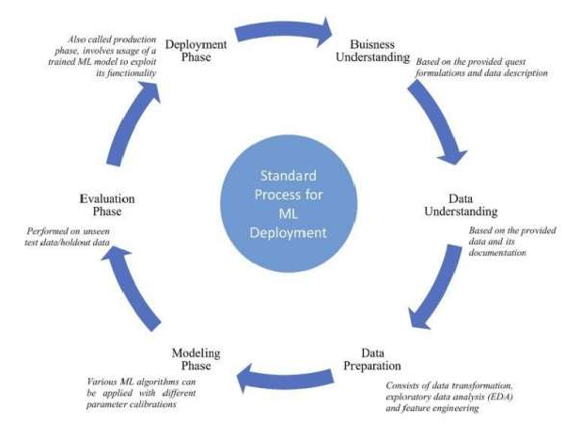

# A PROJECT DESCRIPTION:

Customer churn is often referred to as customer attrition, or customer defection which is the rate at which the customers are lost. Customer churn is a major problem and one of the most important concerns for large companies. Due to the direct effect on the revenues of the companies, especially in the telecom field, companies are seeking to develop means to predict potential customer to churn. Looking at churn, different reasons trigger customers to terminate their contracts, for example better price offers, more interesting packages, bad service experiences or change of customers’ personal situations. Customer churn has become highly important for companies because of increasing competition among companies, increased importance of marketing strategies and conscious behaviour of customers in the recent years. Customers can easily trend toward alternative services. Companies must develop various strategies to prevent these possible trends, depending on the services they provide. During the estimation of possible churns, data from the previous churns might be used. An efficient churn predictive model benefits companies in many ways. Early identification of customers likely to leave may help to build cost effective ways in marketing strategies. Customer retention campaigns might be limited to selected customers but it should cover most of the customer. Incorrect predictions could result in a company losing profits because of the discounts offered to continuous subscribers. Telecommunication industry always suffers from a very high churn rates when one industry offers a better plan than the previous there is a high possibility of the customer churning from the present due to a better plan in such a scenario it is very difficult to avoid losses but through prediction we can keep it to a minimal level. Telecom companies often use customer churn as a key business metrics to predict the number of customers that will leave a telecom service provider. A machine learning model can be used to identity the probable churn customers and then makes the necessary business decisions.

# Project Flow:

* User interacts with the UI to enter the input.
* Entered input is analysed by the model which is integrated.
* Once model analyses the input the prediction is showcased on the UI To accomplish this, we have to complete all the activities listed below,
* Define Problem / Problem Understanding
  + Specify the business problem
  + Business requirements ○ Literature Survey
  + Social or Business Impact.
* Data Collection & Preparation
  + Collect the dataset
  + Data Preparation
* Exploratory Data Analysis
  + Descriptive statistical
  + Visual Analysis
* Model Building
  + Training the model in multiple algorithms
  + Testing the model
* Performance Testing & Hyperparameter Tuning
  + Testing model with multiple evaluation metrics
  + Comparing model accuracy before & after applying hyperparameter tuning
* Model Deployment
  + Save the best model
  + Integrate with Web Framework
* Project Demonstration & Documentation
  + Record explanation Video for project end to end solution
  + Project Documentation-Step by step project development procedure

# Project Structure:

Create a Project folder which contains files as shown below

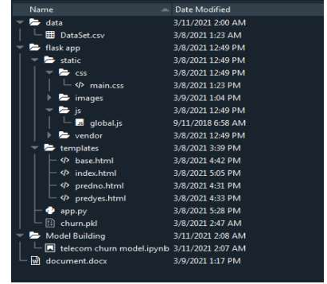

* A python file called app.py for server side scipting.
* We need the model which is saved and the saved model in this content is churn.pkl
* Templates folder which contains base.HTML file, index.HTML file, predyes.HTML , predno.HTML file.
* Static folder which contains css folder which contains main.css , js folder which contains global.js , images folder and vendor folder.

# PURPOSE:

Machine Learning has an additional benefit of processing large chunks of data that is sometimes tire some for men to do and eventually lead to a failure in making the right decision .It is easily adaptable to new and complex data. After processing the data, it is capable of analyzing any flaw so r errors. These also help in creating effective plans of Actions for improvement. There is acceleration between inputs and outputs in the process of decision-making. These points are extremely useful for ventures that work mainly around risk management.

# PROBLEM DEFINITION AND DESIGN THINKING

Machine learning has become an increasingly popular too recent years, given its ability to automatically detect pattern sin data and make predictions about future events. This can be extremely useful for making decisions in a wide range of domains, from financial trading to medical diagnoses.

# EMPATHY MAP

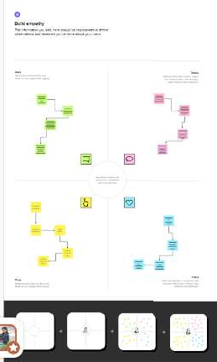

* 1. **Ideation and Brainstorming Map:**

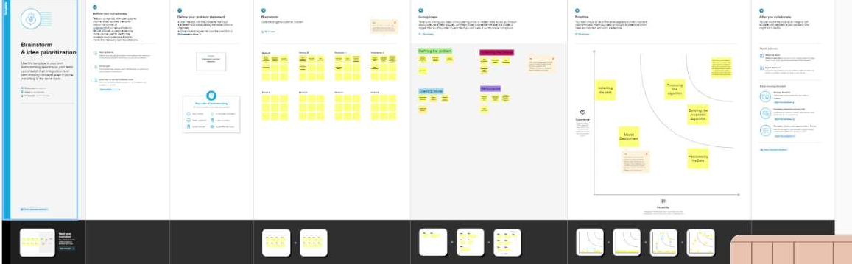

# RESULT:

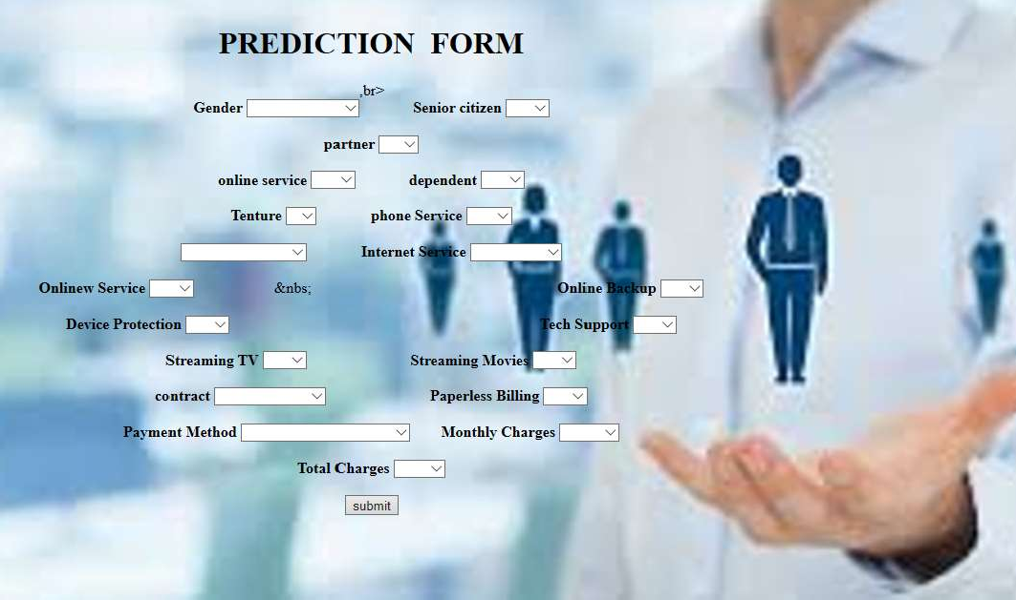

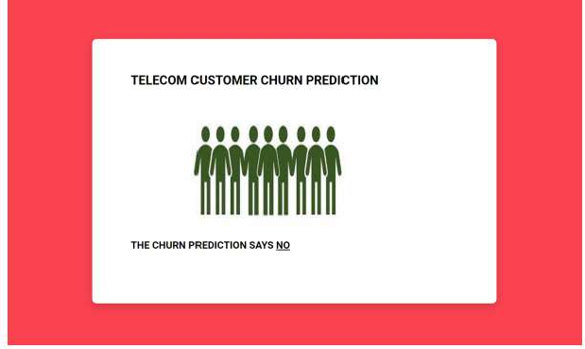

1. **ADVANTAGE AND DISADVANTAGE:**

## Advantage:

1. **Providing better information:** Since machine learning technology can sift through extremely large amounts of data, it is able to also provide better information to decision makers.
2. **Automating the process:** In many industries, it is simply not possible for human beings to make optimal decisions all of the time .This is especially true in industries where the data is constantly changing, such as financial markets .In these cases, machine learning algorithm can be used to automatically make decisions as trends change and evolve.
3. **Improving accuracy:** By identifying patterns in data that humans may not be ableto see, machine learning can drastically improve the accuracy of its predictions. It can also create models that simulate different decision scenarios and help identify the best course of action. And as new data becomes available, machine learning can be used to constantly update and refine decision models.

## Disadvantage:

1. **Data Acquisition**

Machine Learning requires massive data sets to train on , and these should be inclusive/unbiased, and of good quality .There can also be times where they must wait for new data to be generated.

## Time and Resources

ML needs enough time to let the algorithms learn and develop enough to fulfill their purpose with a considerable amount of accuracy and relevancy .It also needs massive resources to function.This can mean additional requirements of computer power for you.

## Interpretation of Results

Another major challenge is the ability to accurately interpret results generated by the algorithms

.You must also carefully choose the algorithms for your purpose.

## High error-susceptibility

Machine Learning is autonomous but highly susceptible to errors .Suppose you train an algorithm with data sets small enough on it be inclusive .You end up with biased predictions coming from a biased training set . This leads to irrelevant advertisements being displayed to customers .In the case of ML, such blunder scan set off a chain of errors that can go undetected for long periods of time . And when they do get noticed , it takes quite some time to recognize the source of the issue ,and even longer to correct it.

## APPLICATION

1. **Decisions in business operations**

Machine Leaíning algorithms come to the íescue in aíeas built on a constant flow of heterogeneous data, whether it is several financial reports, payrolls, procurement, the analysis of employee productivity, or predicting further churn rates. Overall, AI, in terms of inner business processes, is able to leverage business intelligence and make a company data-driven in many aspects, including decision making.

## Complex problem-solving

The potential of AI in decision making is robust, but you can solve multilayer and complex problems, too. Artificial Intelligence here gathers tons of different data and conducts an inter disciplinary study. Eventually, there’s a way to leverage anything from product development stages to digital marketing approaches of product píomotion. Also, it’s a way to optimize various types of predictions and risk management. For example, you can predict and optimize píicing with the help of AI tools.

## Strategic changes

AI allows better planning of production, managing all restrictions, reducing shortcomings in operations, and improving manufacturing*.* It also helps to anticipate and adequately plan product customization, enhance postponement processes, and maintain efficiency with high levels of customer satisfaction

## Customer-related decisions

Al can be valuable for customer service management, personalized customer communication, evaluation of customer behavior, predicting consumer trends and patterns. Artificial intelligence enables automatic recognition and profiling of potential customers.

## Performance assessment

Firstly, it relates to people’s performance evaluation and afterward decisions. AI is capable of minimizing human errors and making employee performance data moíe transparent.AI can also recommend online courses, training, and development programs to employees based on their performance history.

## CONCLUSION

Customer retention was determined as the way to keep the customers in house, maintain the customer relationship and the improvement of the level of customer service. The improvement of the level of customer service was seen as the end result of the activities the customer dissatisfaction causes. Overall, being part of the customer retention was experienced to be hard. Coping with the anger customer might have when being in contact with the company was experienced either harder to manage or easier to manage depending on the root cause.

Listening to them and understanding their needs. Never miss out on any opportunity to surprise your customers. Try to deliver better service at a lower cost, do more than they were expecting. Treat them as special people and you will for sure improve customer retention programs.

## FUTURE SCOPE

With the help of machine learning services like SDKs and APIs, developers are able to include and hone the intelligent capabilities into their applications. This will empower machines to apply the various things they come across, and accordingly carry out an array of duties like vision recognition, speech detection, and understanding of speech and dialect.

## APPENDIX SourceCode:

import pandas as pd import numpy as np import pickle

import matplotlib.pyplot as plt

%matplotlib inline import seaborn as sns import sklearn

from sklearn.preprocessing import LabelEncoder, OneHotEncoder from sklearn.linear_model import LogisticRegression

from sklearn.tree import DecisionTreeClassifier

from sklearn.ensemble import from sklearn.neighbors import from sklearn.svm import SVC from sklearn.model_selection import imblearn

RandomForestClassifier KNeighborsClassifier

import RandomizedSearchCV

from imblearn.over_sampling import SMOTE

from sklearn.model_selection import train_test_split

from sklearn.preprocessing import StandardScaler

from sklearn.metrics import accuracy_score, classification_report, confusion_matrix, f1_s core

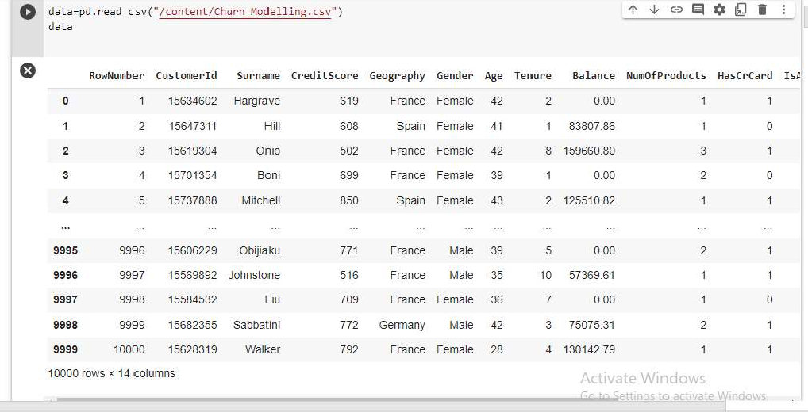

data=data.rename(columns={‘Chance of Admit’:`Chance of Admit’})

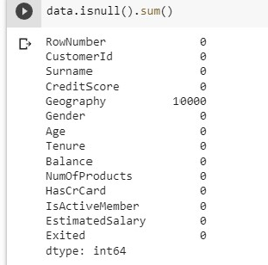

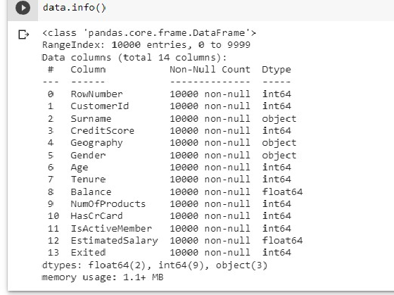

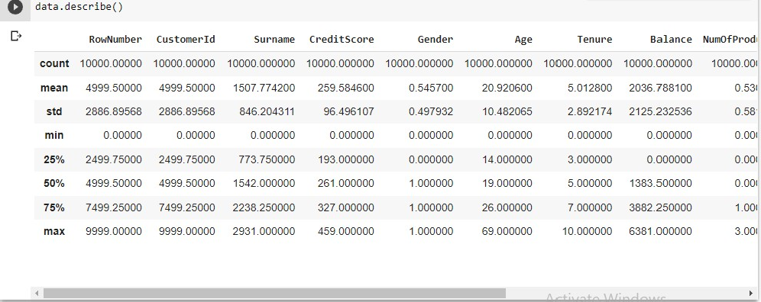

# Visual analysis Univariate

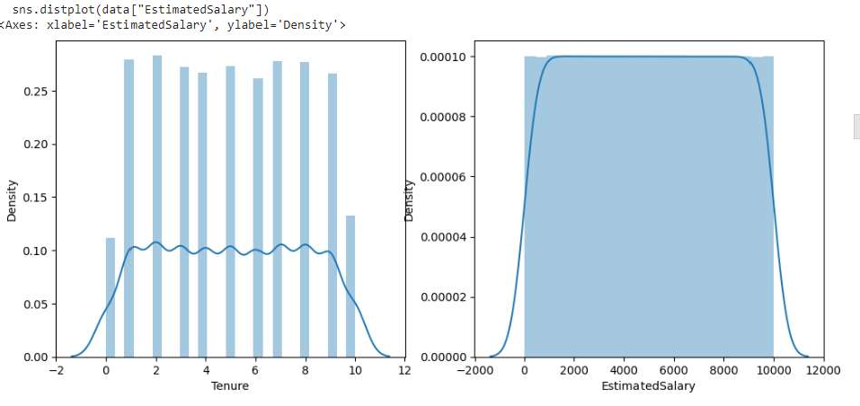

**Analysis Bivariate analysis**

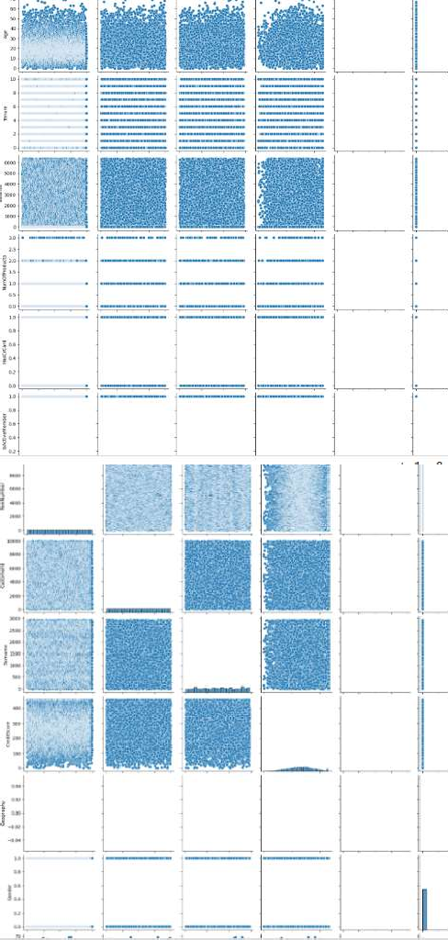

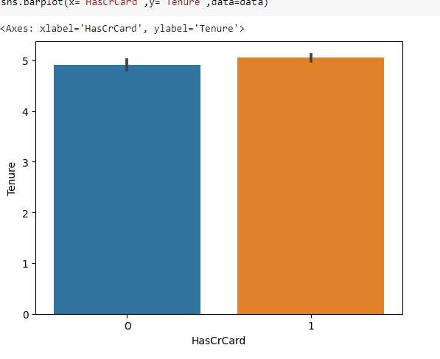

## Intelligent Customer Retention: Using Machine Learning for Enhanced Prediction of Telecom Customer Churn

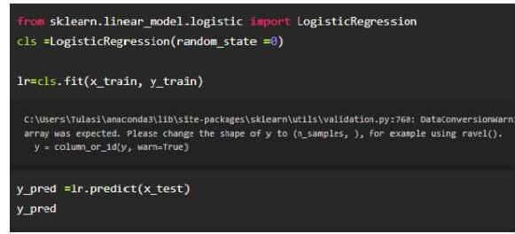

**ModelDeployment::Savethebestmodel:**

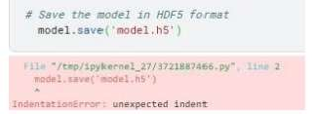

## IntegratewithWebFramework:

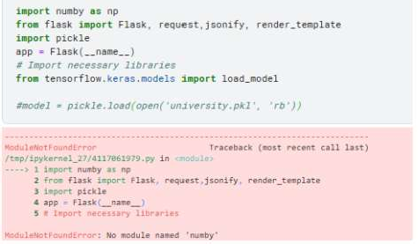

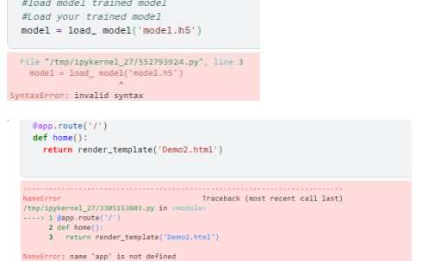

**RetrievesthevaluefromUI:**

